**DE-33 (DCE)**



**NUST COLLEGE OF**

**ELECTRICAL AND MECHANICAL ENGINEERING**



**EYE EXPLORER**

A PROJECT REPORT

DE-33 (DCE)

***Submitted by***

NS Ahmad Tariq

NS Albab Ahmad Khan

NS Faraz Tahir

NS Mujahid Abbas

**BACHELORS**

**IN**

**COMPUTER ENGINEERING**

**YEAR**

**2015**

**PROJECT SUPERVISOR**

**YEAR 2015**

Dr. Usman Akram

**COLLEGE OF ELECTRICAL & MECHANICAL ENGINEERING**

**PESHAWAR ROAD, RAWALPINDI**

**DECLARATION**

We hereby declare that no portion of the work referred to in this Project Thesis has been submitted in support of an application for another degree or qualification of this of any other university or other institute of learning. If any act of plagiarism found, we are fully responsible for every disciplinary action taken against us depending upon the seriousness of the proven offence, even the cancellation of our degree.

**COPYRIGHT STATEMENT**

* Copyright in text of this thesis rests with the student author. Copies (by any process) either in full, or of extracts, may be made **only** in accordance with instructions given by the author and lodged in the Library of NUST College of E&ME. Details may be obtained by the Librarian. This page must form part of any such copies made. Further copies (by any process) of copies made in accordance with such instructions may not be made without the permission (in writing) of the author.
* The ownership of any intellectual property rights which may be described in this thesis is vested in NUST College of E&ME, subject to any prior agreement to the contrary, and may not be made available for use by third parties without the written permission of the College of E&ME, which will prescribe the terms and conditions of any such agreement.
* Further information on the conditions under which disclosures and exploitation may take place is available from the Library of NUST College of E&ME, Rawalpindi.

**ACKNOWLEDGEMENTS**

In the name of Almighty Allah, the Most Gracious and the Most Merciful

All praises for Allah, for He is the Master of Universe and has Absolute Power over everything. He has given us the will and the strength to see this project to completion despite our doubts.

Upon the completion of this odyssey, we are indebted to a lot of people who have offered their kind and constant guidance throughout the journey.

Firstly we would like offer gratitude to our supervisor, Dr. Usman Akram, to be our mentor, guiding us on every step to see this project to success. Sir we thank you of being tolerant of our carelessness. It is due to your efforts that we overcame all the obstacles in the most fluent way.

We would also like to acknowledge Dr. Kamran from Al Latif Trust, Gujranwala and Dr. Nuzhat Qaiser from Family Hospital & Ultrasound Center, Khanewal for their correspondence and providing us the related data sets for our project.

**TABLE OF CONTENTS**

**List of Figures**…………………………………………………………………………...06

**Abstract**………………………………………………………………………………….07

**Chapter One**

Introduction

1.1 Motivation ……………………….……………………………………….………... 09

1.2 Scope ……………………………………………………………………………… 12

1.3 Overall System…………………………………………………………………….. 13

1.3 Structure of Thesis…………………………………………………………………. 14

**Chapter Two**

Cataract & Anemia

2.1 Anemia………………………………………………………………………………15

2.2 Cataract…………………………..………………………………………………… 19

**Chapter Three**

Background & Overview

3.1 Literature Review Anemia….………………………………………………………22

3.2 Literature Review Cataract………………………………………………………… 22

**References**…………………………………………………………………………….…25

**LIST OF FIGURES**

Figure 1.1 Worldwide Surgical Rates for Cataract…....…....…....…....…...........Page No 9

Figure 1.2 Surgical Rates of Cataract in USA………………………………..Page No 10

Figure 1.3 Extracting Blood for checking hemoglobin……………………….Page No 11

Figure 1.4 Flow of work for the localization of Iris/Pupil……………………Page No 11

Figure 1.5 Worldwide statistics of Anemia…………………………………...Page No 12

Figure 1.6 Flow of work for the localization of Iris/Pupil…………………….Page No 13

Figure 1.7 Flow of work for the localization of Iris/Pupil…………………….Page No 14

Figure 1.8 Normal Hemoglobin and Hematocrit Ranges…………………….. Page No 16

Figure 1.9 Hemoglobin ranges for Anemia of pregnant, non-pregnant

women and children……………………………………………………………Page No 16

Figure 1.10 Prevalence of Anemia among children (percentage of

children under 5) ...…………………………………………………………… Page No 17

**ABSTRACT**

Human Eye is the most complex part of the human body but it helps to reveal information about several diseases. Among these diseases are Anemia and Cataract. Anemia is a condition in which there is a deficiency of hemoglobin in the red blood cells, whereas cataract is an eye disease that causes clouding of the eye lens that causes permanent blindness if not treated in time. Anemia is diagnosed by measuring hemoglobin by drawing blood from the body and Cataract is diagnosed by first dilating the pupil and then examining the eye in the slit lamp. Both of the above methods are invasive that involve direct contact with the human body in one way or another. Computer Aided Diagnostic (CAD) systems with their mobility of usage in low resource settings can be very useful for the detection of Anemia and Cataract. We have put forward an idea in the form of mobile application named EYE XPLORER that determines the user’s risk of being anemic or having a cataract just by taking a picture from a smartphone camera. The user for the diagnosis of anemia first lowers his/ her conjunctiva and takes image and then our method first localizes the conjunctiva region from the image. Localization bins are formed to assess the hemoglobin value that further assesses the degree of anemia. For the diagnosis of Cataract, the user takes a picture of his/her eye with retina in focus. Then our proposed method localizes the iris and the pupil of the eye. Texture analysis of the obtained image is performed enabling us to tell whether the eye is normal or it has a cataract. The system is developed and tested using locally gathered dataset of anemia and cataract.

**Chapter One**

**Introduction**

Information Technology has advanced a great deal in the past few decades. It has taken place in our lives as a core component. One of the important parts of IT is Digital Image Processing. It is surprising to find the applications of image processing in almost every professional field and it has helped a lot to make processes easier. While image processing has found its use in industry, it has also played an important role in the research and development.

Before the advancement of technology, diagnosis of a disease was expensive and had large probability of error. Some of the diseases couldn’t even be diagnosed due to the limitations of the lab equipment. Whatever equipment was present was expensive and rare. The doctors would perform different tests to see the anomalies but they still couldn’t get very accurate results.

Digital Image Processing has revolutionized the field of medical sciences. It can be used in diagnosis, monitoring, and treatment of diseases. Many diseases are nowadays diagnosed using the concepts and techniques of image processing. It has made diagnosis relatively cheaper and much more accurate than before.

To make things easier, studies are being made to use noninvasive methods to diagnose a disease. Nowadays, Gadgets and other mobile applications are being developed to help ease the process of daily health care, so that a person can, while remaining in his house, do an overall checkup of his/her body. A good example can be the Apple’s new Health application that comes with its products.

Human eye can be a source of diagnosing many diseases like Cataract, Anemia, Diabetes, Glaucoma, high cholesterol, Conjunctivitis etc.

**Motivation**

Human eye is an organ which can portray many diseases. Two of the most important diseases that can be diagnosed through eyes are Cataract and Anemia.

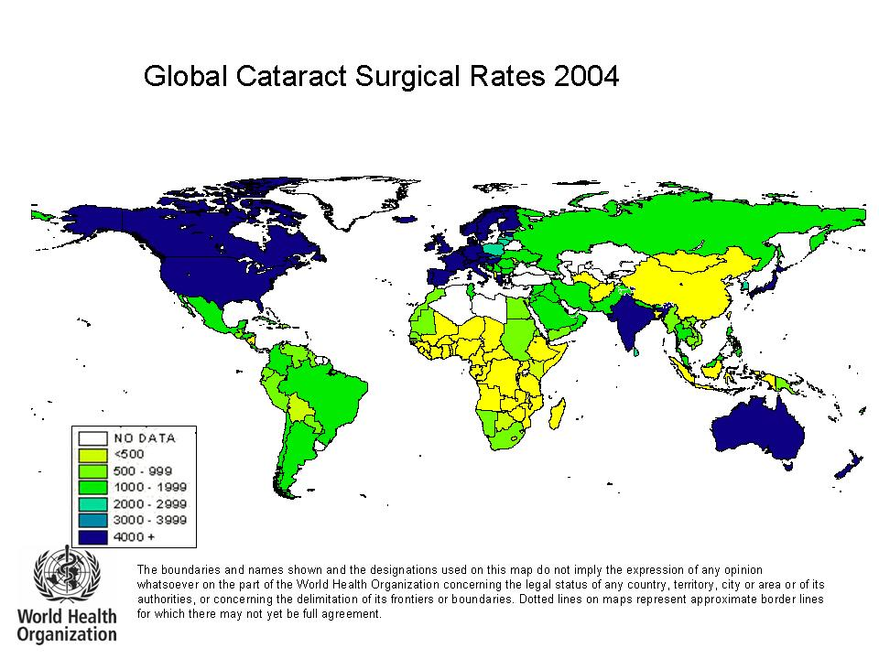

Figure 1.1: Worldwide Surgical Rates for Cataract [1].

A cataract is a clouding of the lens inside the eye which leads to a decrease in vision. It is the most common cause of blindness worldwide and is conventionally treated with surgery [2]. According to the report published in 1998 by The World Health Report, there are estimated 19.34 million people who are bilaterally blind from age-related cataract [3]. This represented 43% of all the blindness.

According to the WHO, the cataract is the leading cause of blindness and visual impairment in the world [4].

.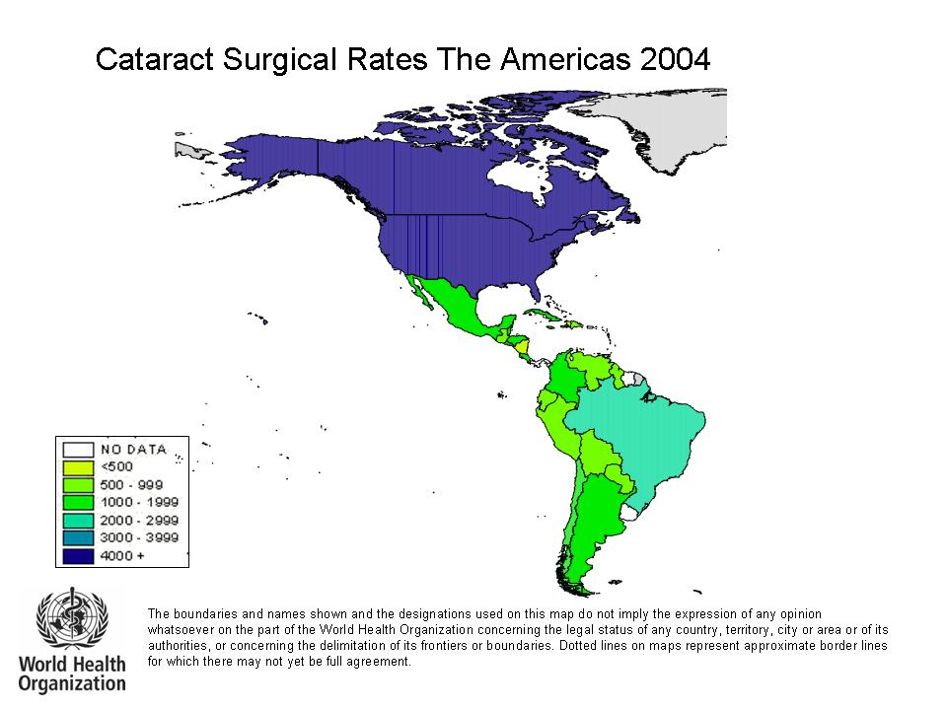

Figure 1.2: Surgical Rates of Cataract in USA [5].

In America, there are almost 22 million people of ages 40 and older suffer from cataract. In their 80’s, more than half of Americans have cataract. The estimated costs for the treatment of cataract annually are around 6.8 billion USD [6]. The doctor to patient ratio is very low. For example the number of ophthalmologists in USA are 18,305 and those all over the world are approximately 200,000 [7].

Anemia is a condition defined as the decrease in the amount of red blood cells or hemoglobin in the blood. It can also be defined as the ability of the blood to carry oxygen [8].

Usually, Anemia is diagnosed by invasive methods, such as filter paper method, copper sulfate method. All these methods involve extraction of blood from the body.

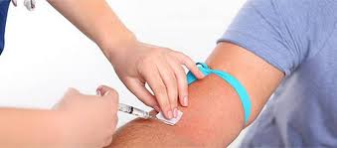

Figure 1.3 Extracting Blood for checking hemoglobin []

The unbalance doctor to patient ratio and the invasive techniques used to diagnose both these diseases persuaded us to come forward with an application that would be able to diagnose these two diseases using noninvasive methods.

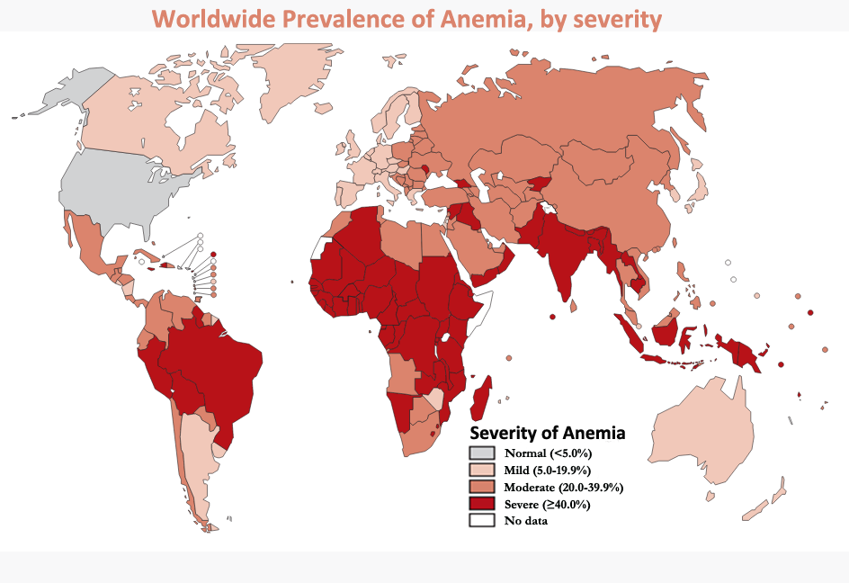

Figure 1.4 Estimation of anemia prevalence by vulnerable group and region [9]

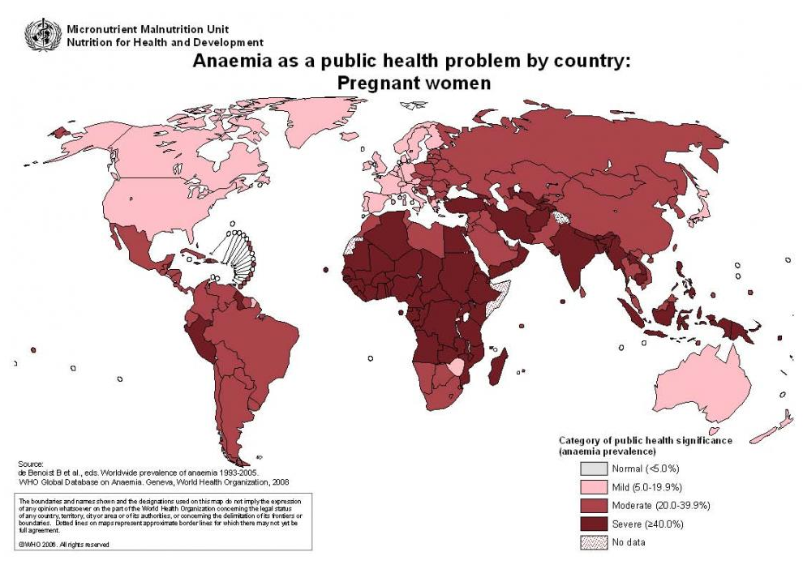

Figure 1.5: Worldwide statistics of Anemia [10]

**Scope**

Our project is a mobile application that enables the users to be able to diagnose cataract and anemia by using a mobile camera. The diagnosis involves acquiring an image of the subject’s eye and running it through an algorithm developed using the techniques and concepts of image processing and then classifying the image as normal or abnormal using classification through texture analysis. The overall system is based on a mobile phone and a host machine which would communicate with each other

**Overall System**

**Anemia**

The overall system of the identification of Anemia is shown in Figure 1.5. The main steps of the procedure is as follows:

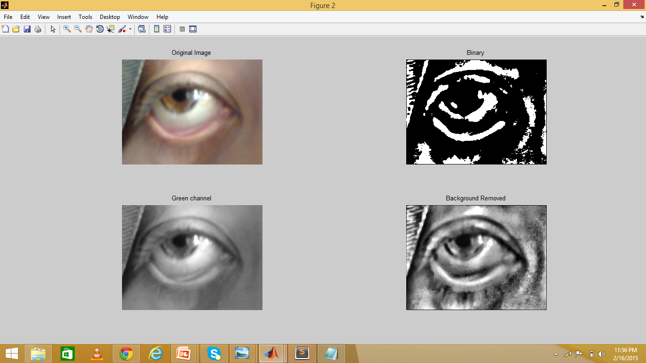 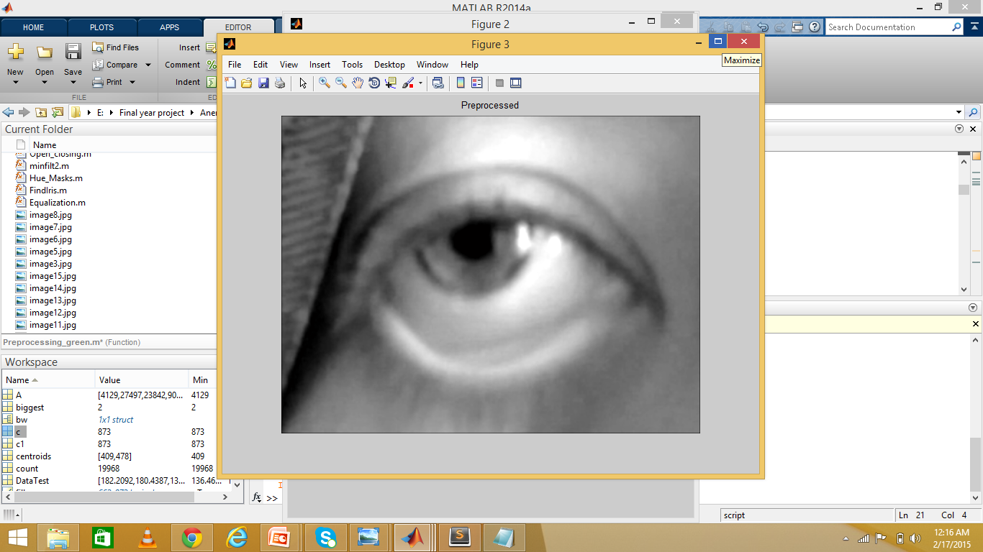

CLAHE (Clip Limit Adaptive Histogram Equalization)

***Pre-Processing***

* Red channel Extraction
* Image Intensity Adjustment
* Median Filtering
* Averaging Filter
* Gaussian Filter

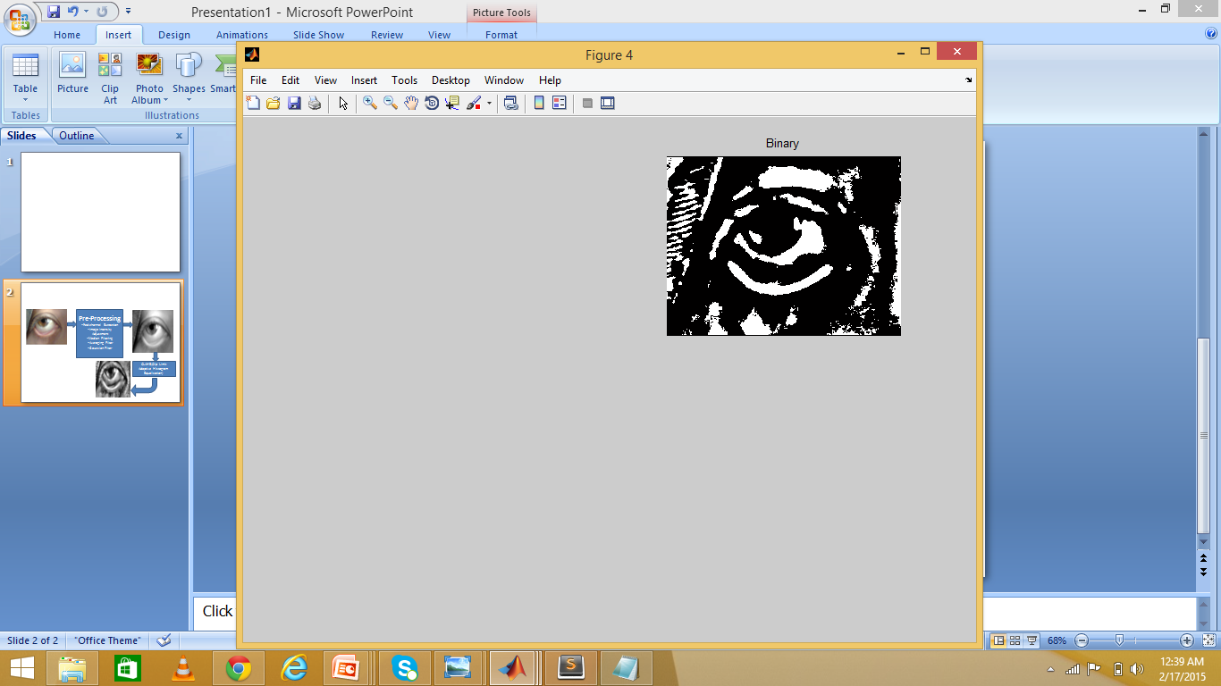 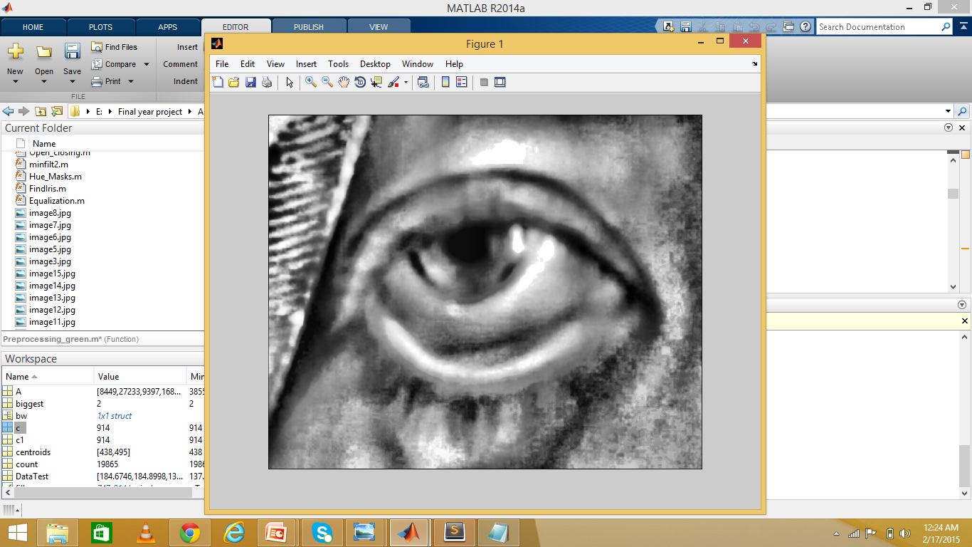

Image Translated Dilation + boundary masking with upper boundary of size R/3+Object Selection Based On Largest Area

Thresholding

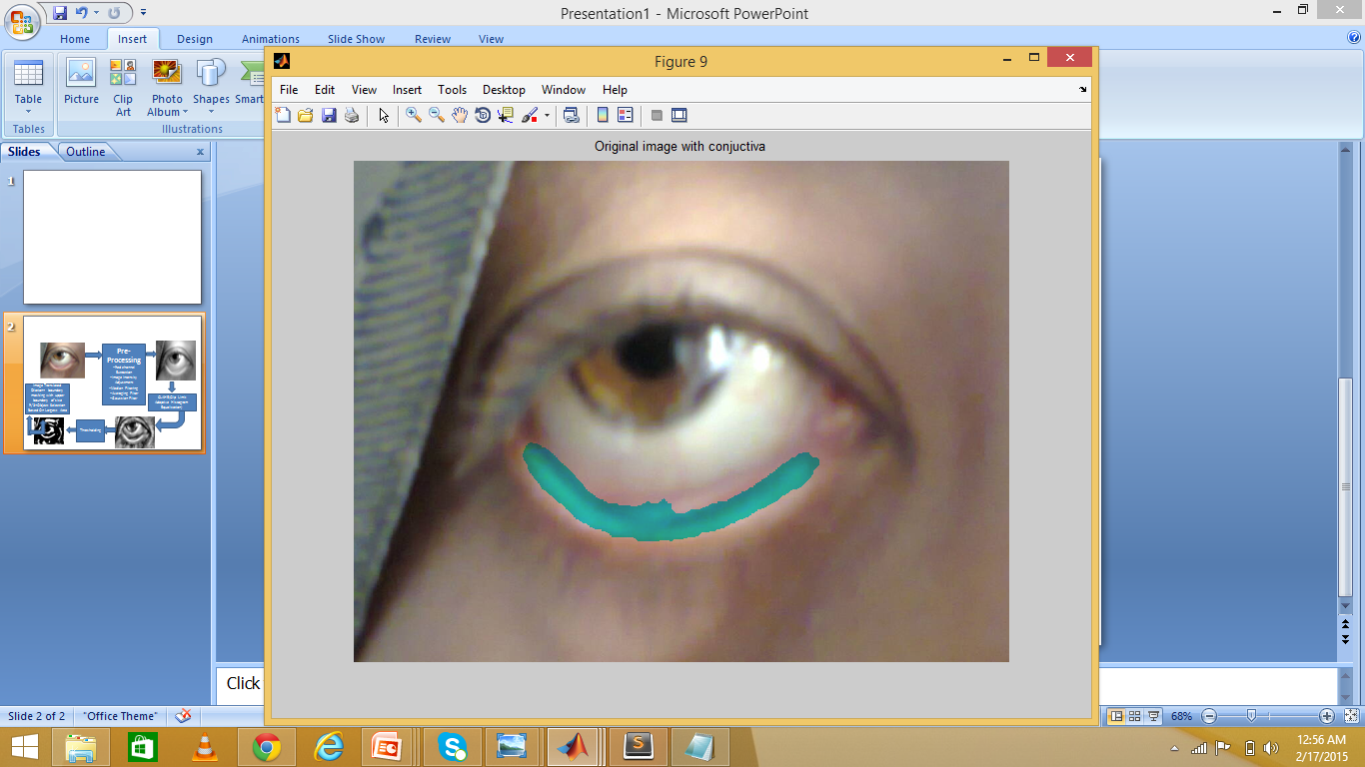

Figure1.6: Flow of work for the localization of Iris/Pupil

The process includes preprocessing of the image taken of the eye. The preprocessing includes the red channel extraction and then the image intensity adjustment. Median and averaging filter is applied on the resulting image and Gaussian filter is applied on it. After the preprocessing clip limit adaptive histogram equalization is applied on the image and thresh holding and the image translated and boundary masking with upper boundary of size R/3+Object Selection Based On Largest Area.

**Cataract**

The overall system that detects the cataract is shown in Figure 1.4. The main steps are listed below:

Localized Iris/Pupil

Cropped Image

Processing for iris/pupil localization

Image Acquisition

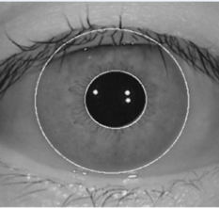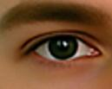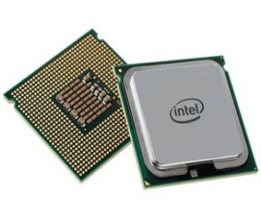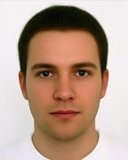

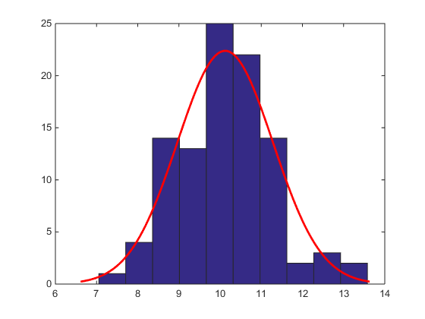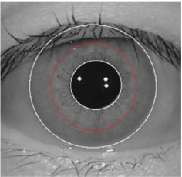

Texture Analysis

Classification

Intensity Normalization

ROI around Pupil

Figure1.7: Flow of work for the localization of Iris/Pupil

* Acquiring the image of the subject
* Cropping the image to avoid other details of the face
* Running the image through iris/pupil localization algorithm to detect iris and pupil
* Figuring out the Region Of Interest
* Using texture analysis techniques to classify between normal and abnormal images

**Structure of Thesis**

This thesis introduces the diseases that are under consideration. Then it explores their statistics, causes and their types. In the next part, this thesis explains the pervious methods that were proposed to detect/diagnose these diseases. Our methodology comes next. We have explained the method adopted by us and the algorithm developed in detail covering every little detail. Finally we come to the conclusion and the future work that can be done to further expand our project or to further improve the methodology and any shortcoming that may have remained.

**Chapter Two**

**Anemia & Cataract**

**Anemia**

Anemia is a disease which is caused mainly by the deficiency of red blood cells or deficiency of hemoglobin in the blood resulting in pale appearance of the patient and weariness. Hemoglobin is actually the primary portion of red blood cells and bind Oxygen. Having a very few red blood cells or if the hemoglobin level is low in the body, the cells don’t get enough amount of oxygen. Anemia is one of the most common blood conditions which is affecting a large number of patients around the globe. Anemia is caused because of one or more processes briefed as follows:

* Defectiveness in the formation of red blood cells because of diet lacking essential nutrients, deficiency of iron, or increased utilization of nutrients such as during pregnancy, lactation, or rapid menstrual cycles.
* Rapid number of red cell destruction because of parasitic conditions like malaria or sickle cell anemia (genetic condition) or thalassemia.
* Blood loss which is because of hookworm of large menstrual flow.

The common way to depict the state of Anemia is by measuring the hemoglobin of the patient. (Oxygen carrying component in red blood cells) or by estimating the hematocrit.

Following are some of the types of Anemia:

* Iron Deficiency anemia
* Thalassemia
* Aplastic Anemia
* Hemolytic Anemia
* Sickle Cell Anemia
* Pernicious Anemia
* Fanconi Anemia

The most commonly found type of anemia is Iron Deficiency Anemia. The normal range of Hemoglobin is:

Figure: 1.8 Normal Hemoglobin and Hematocrit Ranges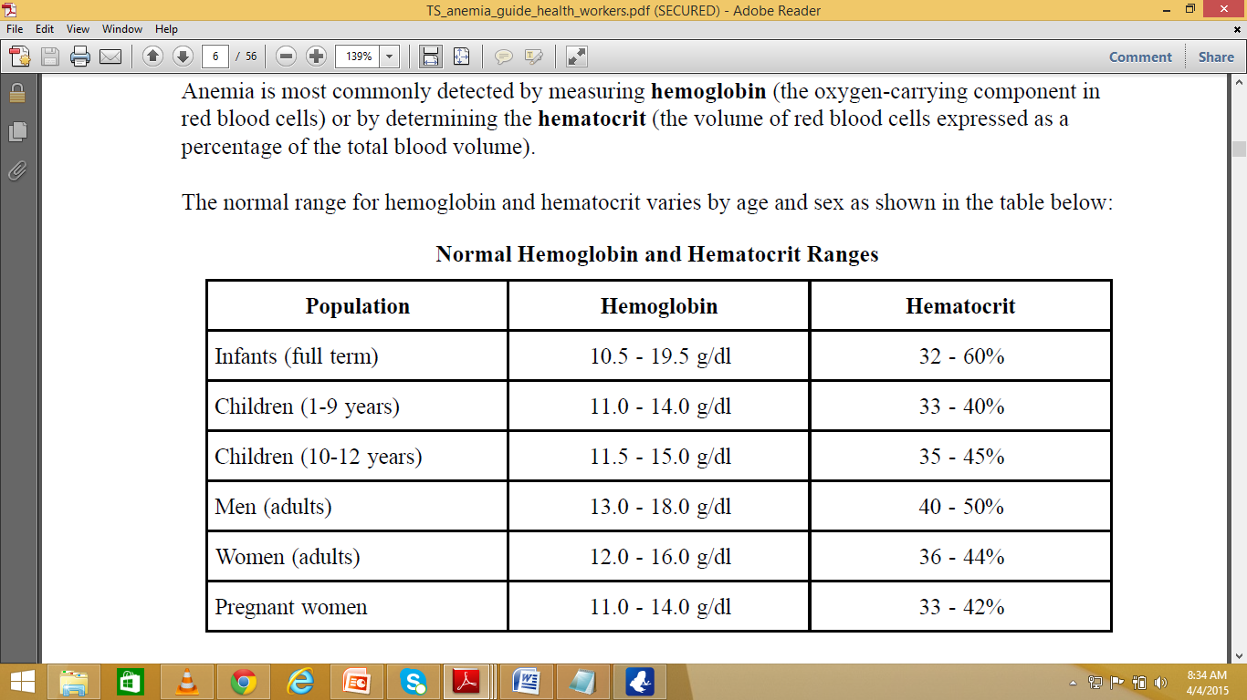

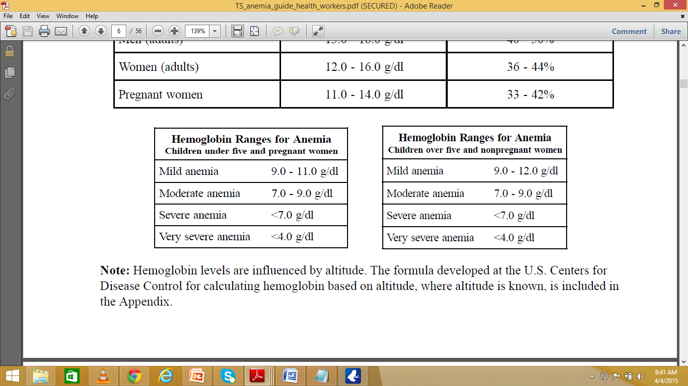Figure: 1.9 Hemoglobin ranges for Anemia of pregnant, non-pregnant women and children

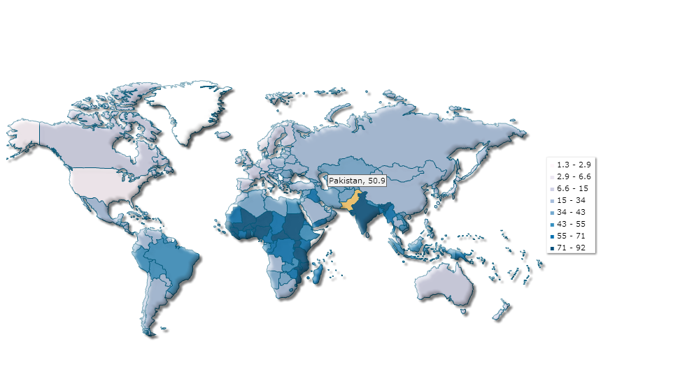

# Figure: 1.10 Prevalence of Anemia among children (percentage of children under 5) [12]

**Invasive Methods of measuring Hemoglobin:**

Some of the methods of measuring hemoglobin values from blood samples are as follows:

**Filter Paper Method:**

Red color in the blood can be illustrator as a pointer of the hemoglobin present in the body. Degree of Anemia can be visualized by matching the color of the blood on the filter paper with the standardized color chart. The color chart has been developed to represent the color range of normal to anemic blood on filter paper.

**Copper Sulfate Method:**

### The specific gravity of blood is influenced by red blood cell volume. The copper sulfate test is based on the fall (or flotation) of whole blood when dropped into a copper sulfate solution of a known specific gravity. The drop of blood will either float or sink depending on whether it is lighter or heavier than the copper sulfate solution. Standard copper sulfate solutions are used to determine a particular hemoglobin level [12].

**Hematocrit by Centrifuge:**

The hematocrit level, or packed cell volume, is a measure of the ratio of the volume of red cells to the total volume of whole blood (plasma, white blood cells, and red blood cells) and is expressed as a percentage. The ratio is determined after centrifugation. The hematocrit level is approximately 3 times the hemoglobin level [13].

**Lovibond type Comparator:**

The Lovibond visual color comparison method is based on comparing the depth of color that results when an accurate measurement of blood is added to a diluting fluid with a set of colored glass standards. The hemoglobin in the blood is converted to oxy-hemoglobin or hemoglobin cyanide depending on which diluting fluid is used. The color of the test solution is visually compared with a set of glass standards set in a disc that match the diluted hemoglobin fluid. The intensity of color in the test solution corresponds to a specific hemoglobin level. [14]

**Statistics**

Almost one quarter of the world’s population is anemic. The major divisions which are most at risk of developinganemia include women which are of reproductive age (affected due to menstruation), pregnant women, lactatingwomen and children of the age varying from 6 months to 2 years. Almost one half of the total pregnant women in the world are anemic. In developing countries the ratio is between 55 to 60 percent whereas 18 percent are women are affected in developed countries. Anemia is a fatal disease affecting nearly 1 billion people in the world. In 2013, anemia due to iron deficiency resulted in almost 183,000 deaths.

**Cataract**

According to the World Health Organization (WHO), “Cataract is clouding of the lens of the eye which impedes the passage of light. Although most cases of cataract are related to the ageing process, occasionally children can be born with condition, or a cataract may develop after an eye injury, inflammation, and some other eye diseases” [15]. Cataract scatters the light that passes through the lens rendering the image to be blurred or clouded. Cataract remains the leading cause for blindness.

**Major Causes of Cataract**

* **Ageing:** The main factor for cataract is ageing which is inevitable. The number of people that have cataract will eventually increase as the world population ages. Some statistics show that the 400 million people of aged 60 or less would double to at least 800 million in 2020. This population increase will increase the number of people having a chance of cataract.
* **Trauma:** Any kind of injury to the eye, blunt trauma that causes the eyes to swell can induce cataract in the later stages. The blow can cause swelling, thickening and whitening of the lens. The swelling can heal with time but the white color remains. Other injuries that penetrate the eyes can damage the place where the lens rests, allowing the water to swell and whiten the lens. This obstructs light to go to the retina.
* **Ultraviolet Light:** Ultraviolet radiation and Microwave radiation can cause cataract though the mechanism is unclear till today but there are theories presents that suggests the link of cataracts to radiation exposure.

One theory suggests that the radiation causes the heat sensitive enzymes that protect the proteins in the lens. Other suggests that the damage dealt to the lens with direct exposure to pressure waves induced in the aqueous humor

* **Genetics:** Genes can be a major component in the formation of cataracts.
* **Smoking:** Smoking causes the rate of having nuclear cataract and triples the rate of posterior cataract.
* **Medication:** Some drugs used as medicines can contribute to the development of cataracts like steroids and other medications taken to control the diabetes [16].

**Types of Cataracts**

* **Nuclear Sclerotic Cataract:**  The major cause of cataracts is the ageing problem that hardens the lens and makes it yellowish over time as you grow older. The “Nuclear” refers to the central portion of the lens which gets clouded and yellowish. “Sclerotic” refers to the hardening of sclerosis of the lens nucleus. This type of cataract weakens the ability to focus. (Are there different types of Cataracts? By Tina D. Turner, M.D., Vision Aware, Resources for Independent Living with Vision Loss [17]
* **Cortical:** This type of cataract refers to the whitening of the lens that causes opacity in the cortex region of the lens located outside the lens. It starts as whitish wedge shaped opacities that streak out to the edge of the lens cortex eventually the streaks extend to the center of the lens making the sight blurry. [18]
* **Posterior Sub capsular:** This type of cataract usually starts from the back of the lens hence the word “Posterior” in its type. The sub capsular is for the capsule on which the lens resides. It starts from beneath the capsule. These types of cataracts cause reading problems and tend to produce glare around lightening illuminated things. These are caused by the excessive use of drugs like steroids, or have diabetes and nearsightedness [19]

**Statistics**

* In India alone, almost 3.8 million people become blind each year from cataract [20]
* Despite the fact that the cataract removal surgery is considered as most efficien, safe and cost-effective intervention, people in rural and remote areas become blind due to little or no knowledge of cataract. The percentage of blindness due to cataract among all eye diseases is 5% in developed areas whereas this figure rises up to 50% for rural areas [21].
* Current population of 20 million people with a severely reduced vision of 3/60 or worse due to different types of cataract would be increased to 40 million by the year 2020 as the world population will increase by one third and during this period the population of the people of age 60 or elder will increase by more than double [22].
* An estimated 3.1% of deaths worldwide are directly or indirectly due to cataract, glaucoma, trachoma and onchocerciasis [23]
* Around 50% of blindness in sub-Saharan Africa is due to cataract [24]
* Globally, at least 100 million eyes have visual acuity <6/60 due to cataract [25]
* Globally, the need for cataract operations is at least 30 million per year, but only around 10 million cataract operations are performed annually [26]

**Chapter Three**

**Background & Overview**

**Anemia**

**Literature Review**

Suner *et al.* proposed a way to non-invasively determine the hemoglobin level by taking a digital photograph of Palpebral conjunctiva. He used two arm process named as derivative and evaluation. In the derivation arm of the process he enrolled 44 patients to derive the formula for hemoglobin measurement. Hemoglobin in blood was already calculated using a cell counter. Then he developed a software to predict the hemoglobin values based on the formula derived using the known hemoglobin values and images from a derivation set of the process. He used the Pearson rank order correlation to see the correlation present between the calculated and measured hemoglobin levels. He first manually selected the conjunctiva region and cropped it. That cropped image was then separated into red, green and blue colored channels. Each image was represented by 16 million colors as 256 shades of gray in red, green, and blue component Images (256 * 256 * 256 = 16.7 million). Each pixel was assigned three values between 0 and 255, one for each color layer (0 = black, 255 =white, i.e., [145, 237, 12]).Next a formula utilizing the pixel values from the conjunctiva and standard and constant values were determined by an iterative process to optimize the predicted hemoglobin by comparing the results to known hemoglobin values and repeating the calculation after varying the constants. After the optimal formula was constructed, the process was applied to images prospectively to estimate hemoglobin.

**Cataract**

**Literature Review**

There are a number of methods that have been proposed for the automatic diagnosis of cataract a summary of some is given in the next few paragraphs.

Huiqi *et al*. applied his approach of “Image Based Diagnosis of Cortical Cataract” on 611 test images on which an accuracy of 98.2% was achieved. For the 466 images tested in the process, a mean error of opacity area detection was 3.15% compared with a human grader and 85.6% of exact cortical cataract was obtained. The proposed system first determined the Region of Interest (Detection of Pupil). The cortical opacity was detected by employing the spoke feature to separate from other opacities such as PSC. At first the image was converted into its polar coordinates then local thresh holding and edge detection was applied both in radial and angular direction to detect opacity centers and opacity edges respectively. Both the results were merged and were reverted to Cartesian plot. Angular opacity was subtracted from radial opacity to retain only the cortical opacities as cortical seeds.

Jagadish Nayak presented a method of automated classification of normal, cataract and post cataract optical eye images using SVM classifier. A total of 174 images, roughly of all age groups (male and female), were acquired from Kasturba Medical College, Manipal, India. The images were of size 128x128 pixel. Small Ring Area and Big Ring Area were calculated next and then edge detection was used to compute the EPC 9Edge Pixel Count). The approach used for the detection was based on the fact that in the images having cataract, there are many sudden changes in gray levels hence there are many edges. Erosion was applied with a 3x3 structuring element with all ones. SVM classifier was applied with 4 features i.e. Small Ring Area, Big Ring Area, Edge Pixel Count and Perimeter. A sensitivity of 94% and a specificity of 93.75% was achieved

A method of extracting information from the pupil of the eye for the detection of cataract was proposed by Retno *et al*.using specular reflection analysis. The features were extracted using the specular reflection analysis and statistical texture that consists uniformity and average intensity for handling problems. Support Vector Machine classifier was used to classify the image based on the features that are listed above. The system was tested on 217 images. 137 of the images were declared as serious condition by the eye diagnosis doctor and the other 80 were non-serious. The percentage values of the images declared as True Positive by the proposed system were 91.97% and the percentage of False Positive were 18.75%.

A method for improving cataract screening techniques was proposed by Retno *et al*.

The method proposed first localized the Iris to get the Region of Interest. Six features were extracted namely Average Intensity, Average Contrast, Smoothness, Third Moment, Uniformity and Entropy. The tested data was obtained from Kamandaka Eye Clinic, Indonesia.

In another system proposed by retno *et al.,* the system first localized the pupil region of the eye and the looked for the front and backside reflection on the lens. Then cataract was diagnosed by developing a differential equation model that provided a screen between the normal and serious condition.

**REFERENCES**

[1] Cataract Surgical Rate (CSR), Prevention of Blindness and Visual Impairment, WHO [**http://www.who.int/blindness/data_maps/cataract_surgery_rate/en/**](http://www.who.int/blindness/data_maps/cataract_surgery_rate/en/)access 06-04-15

[2] Cataract, Wikipedia [**http://en.wikipedia.org/wiki/Cataract#cite_note-1**](http://en.wikipedia.org/wiki/Cataract%23cite_note-1)access 06-04-15

[3] The World Health Report: Life in the 21st Century – A Vision for All. World Health Organization, Geneva, 1998. Page 47

[4] Cataract, International Agency for the Prevention of Blindness [**http://www.iapb.org/vision-2020/what-is-avoidable-blindness/cataract**](http://www.iapb.org/vision-2020/what-is-avoidable-blindness/cataract) access 06-04-15

[5] Cataract Surgical Rate (CSR), Prevention of Blindness and Visual Impairment, WHO [**http://www.who.int/blindness/data_maps/CSR_AMRO_2004.jpg?ua=1**](http://www.who.int/blindness/data_maps/CSR_AMRO_2004.jpg?ua=1)Access 06-04-15

[6] Eye Health Statistics at a Glance, Compiled by American Academy of Ophthalmology, updated in 2011. [**http://www.preventblindness.org/vpus/2008_update/VPUS_2008_update.pdf**](http://www.preventblindness.org/vpus/2008_update/VPUS_2008_update.pdf)

[7] Eye Health Statistics at a Glance, Compiled by American Academy of Ophthalmology, updated in 2011.

[8] (Anemia, Wikipedia [**http://en.wikipedia.org/wiki/Anemia**](http://en.wikipedia.org/wiki/Anemia) Access 08-04-15).

[9] ([https://www.k4health.org/toolkits/anemia-prevention/anemia-causes-prevalence-impact Access 9/4/2015](https://www.k4health.org/toolkits/anemia-prevention/anemia-causes-prevalence-impact%20Access%209/4/2015))

[10] ([http://www.doctortipster.com/18547-are-you-anemic.html Access 9/4/2015](http://www.doctortipster.com/18547-are-you-anemic.html%20Access%209/4/2015))

[11] ([http://www.indexmundi.com/facts/indicators/SH.ANM.CHLD.ZS Access 9/4/2015](http://www.indexmundi.com/facts/indicators/SH.ANM.CHLD.ZS%20Access%209/4/2015))

[12] ([Anemia Detection Methods in Low-Resource Settings - Path](https://www.google.com.pk/url?sa=t&rct=j&q=&esrc=s&source=web&cd=1&cad=rja&uact=8&ved=0CBsQFjAA&url=http%3A%2F%2Fwww.path.org%2Fpublications%2Ffiles%2FTS_anemia_guide_health_workers.pdf&ei=JcYkVcOQKsLgaLWxgdAE&usg=AFQjCNHqWpnLK94EniBfNLy7zRze1M1x1A&sig2=LydGoVkF3oF5kFgaYXE1cg) [www.path.org/publications/files/TS_anemia_guide_health_workers.pdf](http://www.path.org/publications/files/TS_anemia_guide_health_workers.pdf)Access: 9/4/2015)

[13] ([Anemia Detection Methods in Low-Resource Settings - Path](https://www.google.com.pk/url?sa=t&rct=j&q=&esrc=s&source=web&cd=1&cad=rja&uact=8&ved=0CBsQFjAA&url=http%3A%2F%2Fwww.path.org%2Fpublications%2Ffiles%2FTS_anemia_guide_health_workers.pdf&ei=JcYkVcOQKsLgaLWxgdAE&usg=AFQjCNHqWpnLK94EniBfNLy7zRze1M1x1A&sig2=LydGoVkF3oF5kFgaYXE1cg) [**www.path.org/publications/files/TS_anemia_guide_health_workers.pdf**](http://www.path.org/publications/files/TS_anemia_guide_health_workers.pdf)Access:9/4/2015)

[14] ([Anemia Detection Methods in Low-Resource Settings - Path](https://www.google.com.pk/url?sa=t&rct=j&q=&esrc=s&source=web&cd=1&cad=rja&uact=8&ved=0CBsQFjAA&url=http%3A%2F%2Fwww.path.org%2Fpublications%2Ffiles%2FTS_anemia_guide_health_workers.pdf&ei=JcYkVcOQKsLgaLWxgdAE&usg=AFQjCNHqWpnLK94EniBfNLy7zRze1M1x1A&sig2=LydGoVkF3oF5kFgaYXE1cg)

[**www.path.org/publications/files/TS_anemia_guide_health_workers.pdf**](http://www.path.org/publications/files/TS_anemia_guide_health_workers.pdf) **Access: 8/4/2015**)

[15] (Cataract, International Agency for the Prevention of Blindness [**http://www.iapb.org/vision-2020/what-is-avoidable-blindness/cataract** Access 07-04-15](http://www.iapb.org/vision-2020/what-is-avoidable-blindness/cataract%20Access%2007-04-15)**)**

[16] (Cataract [**http://en.wikipedia.org/wiki/Cataract#Signs_and_symptoms**](http://en.wikipedia.org/wiki/Cataract%23Signs_and_symptoms)Access 07-04-15**).**

[17] [**http://www.visionaware.org/info/your-eye-condition/cataracts/different-types-of-cataracts/125**](http://www.visionaware.org/info/your-eye-condition/cataracts/different-types-of-cataracts/125%20)Access 07-04-15)

[18] (Causes by Mayo Clinic Staff [**http://www.mayoclinic.org/diseases-conditions/cataracts/basics/causes/con-20015113**](http://www.mayoclinic.org/diseases-conditions/cataracts/basics/causes/con-20015113)Access 07-04-15).

[19] (Are There Different Types of Cataracts? By Tina D. Turner, M.D. [**http://www.visionaware.org/info/your-eye-condition/cataracts/different-types-of-cataracts/125**](http://www.visionaware.org/info/your-eye-condition/cataracts/different-types-of-cataracts/125)Access 07-04-15)

[20] (Minassian DC, Mehra V. 3.8 million blinded by cataract each year. Br J Ophthalmol. 1990; 74:341–43.).

[21] (Cataract, International Agency for the Prevention of Blindness  
( [**http://www.iapb.org/vision-2020/what-is-avoidable-blindness/cataract**](http://www.iapb.org/vision-2020/what-is-avoidable-blindness/cataract) Access 07-04-15)

[22] (Cataract Blindness- challenges for the 21st Century by Garry Brian & Hugh Taylor)

[23] (Murray, CJL and Lopez, AD. Global mortality, disability, and the contribution of risk factors: Global Burden of Disease Study. Lancet. 1997;349:1436-1442)

[24] (Lewallen and Courtright. Blindness in Africa: present situation and future needs. Br J Ophthalmol. 2001 Aug;85(8):897-903).

[25] (Foster A. Cataract--a global perspective: output, outcome and outlay. Eye. 1999;13:65-70)

[26] (Foster A. Cataract--a global perspective: output, outcome and outlay. Eye. 1999;13:65-70)